**CMOS Imaging Sensor Circuit Board Assembly Information**

* Top layer component descriptors: Mechanical layer 5
* Bottom layer component descriptors: Mechanical layer 6 (still need to add)
* Double sided assembly: Yes
* 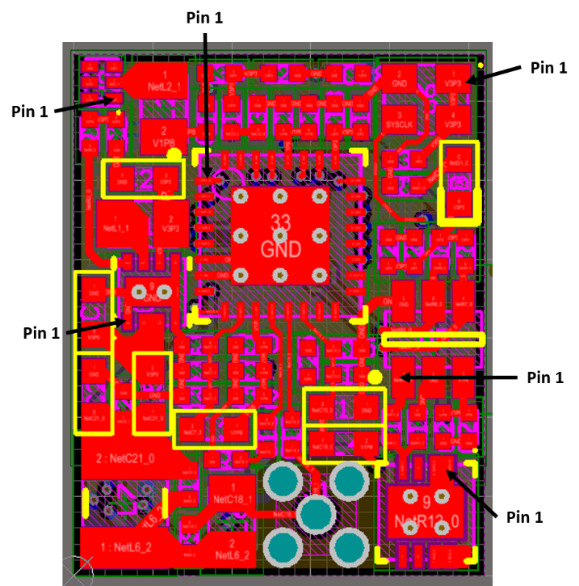Pin 1 identifiers shown below
* D1 (LED) orientation shown below

